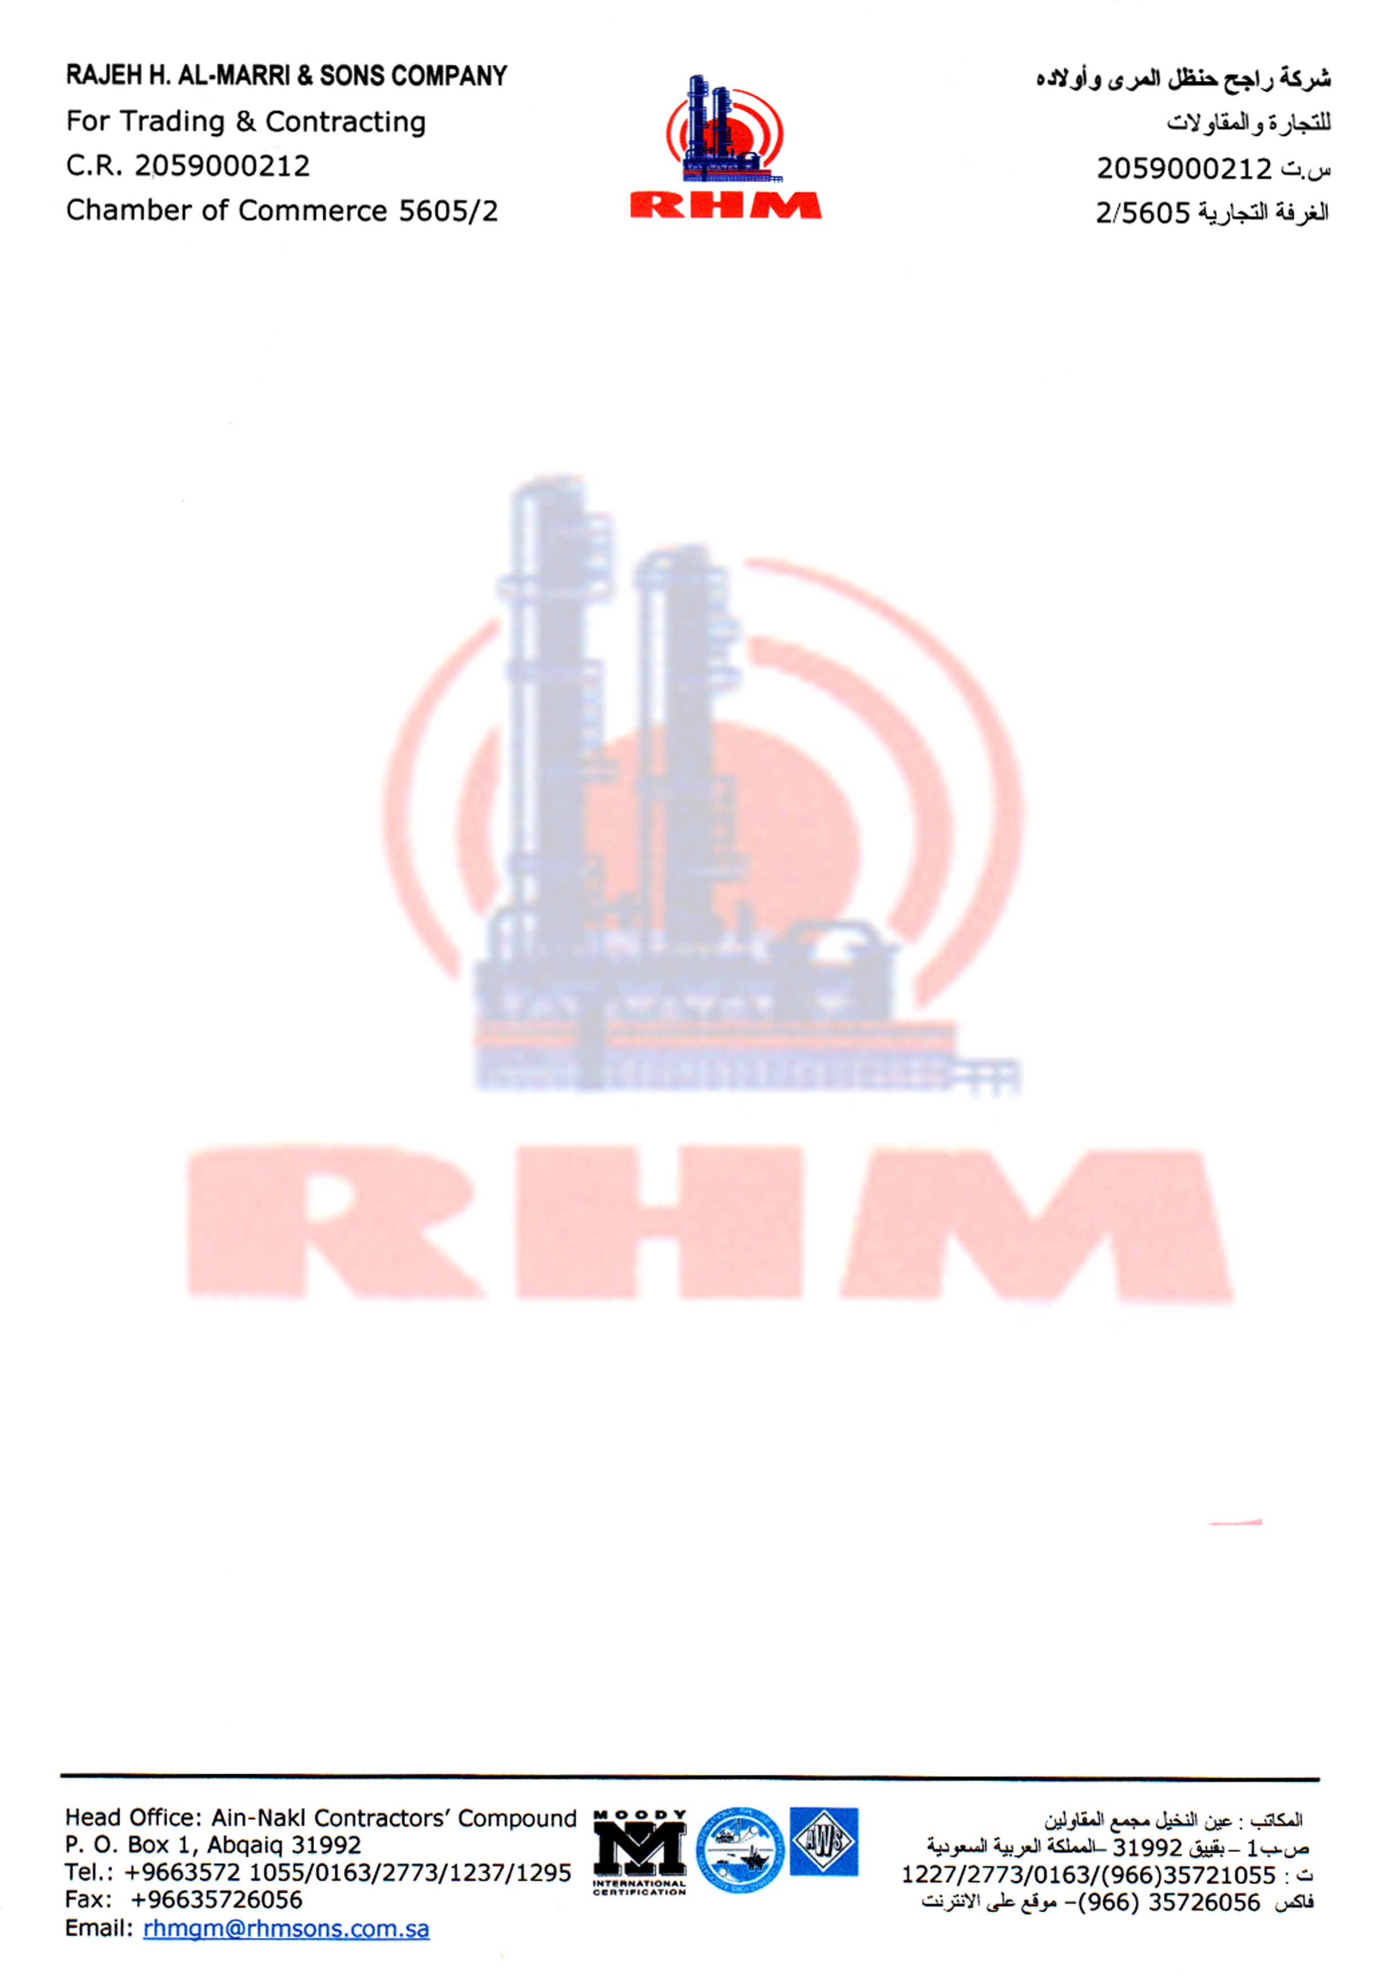

Date: <To> Badge No: 4984

TO WHOM IT MAY CONCERN

This is to certify that Mr. <Name> Pakistan Nationality Holding Passport No. <Passport> was working with Rajeh H. Al-Marri & Sons Company Saudi Arabia from <From> Up to his release date on   
<To> in the different fields listed below:

* <Designation>

This certificate is given to him upon his request without any obligation towards the company.

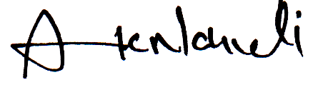

__________________

Alexander

HR Manager